ASSIGNMENT

What are the Transmissions Channel and different channel of it.   
  
What are different IEE Standard for the different channel, architecture and Frame Format.

Draw the Architecture and Different Frame format in the IEE standard.  
  
The IEEE (Institute of Electrical and Electronics Engineers) is a major player in the standards world, with a standardization group that develops standards in electrical engineering and computing. The IEEE's 802 committee has standardized many types of Local Area Networks (LANs).

Here is a list of the IEEE 802 working groups and their respective topics or "channels" (areas

of standardization), as found in the sources:

• **802.1**: **Overview and architecture of LANs**.

• **802.2**: **Logical Link Control** (hibernating).

• **802.3**: **Ethernet**. This is one of the most important standards.

• **802.4**: **Token bus** (was briefly used in manufacturing plants, hibernating).

• **802.5**: **Token ring** (IBM’s entry into the LAN world).

• **802.6**: **Dual queue dual bus** (early metropolitan area network, hibernating).

• **802.7**: **Technical advisory group on broadband technologies** (hibernating).

• **802.8**: Technical advisory group on fiber optic technologies (gave up and disbanded itself).

• **802.9**: **Isochronous LANs** (for real-time applications, hibernating).

• **802.10**: **Virtual LANs and security** (hibernating).

• **802.11**: **Wireless LANs (WiFi)**. This is one of the most important standards. 802.11 systems operate in unlicensed bands such as the ISM (Industrial, Scientific, and Medical) bands. 802.11n, ratified in 2009, doubled channels from 20 MHz to 40 MHz and uses up to four antennas to transmit streams of information simultaneously using MIMO techniques. The standard defines channel sensing, including physical and virtual sensing using a Network Allocation Vector (NAV). Quality of service (QoS) is provided through different interframe spacing intervals (DIFS, SIFS, AIFS).

• **802.12**: **Demand priority** (Hewlett-Packard’s AnyLAN, hibernating).

• **802.13**: Unlucky number; nobody wanted it.

• **802.14**: **Cable modems** (defunct: an industry consortium got there first, hibernating).

• **802.15**: **Personal area networks** (Bluetooth, Zigbee). Bluetooth, though widely deployed, has been standardized outside of 802.15.

• **802.16**: **Broadband wireless (WiMAX)**. This standard is discussed in the sources as a 4G technology, combining aspects of 802.11 and 3G. It was designed to carry IP packets over the air. The WiMAX Forum was created to define interoperable subsets of the standard.

• **802.17**: **Resilient packet ring**.

• **802.18**: Technical advisory group on radio regulatory issues.

• **802.19**: Technical advisory group on coexistence of all these standards.

• **802.20**: **Mobile broadband wireless** (similar to 802.16e).

• **802.21**: **Media independent handoff** (for roaming over technologies).

• **802.22**: **Wireless regional area network**.

The success rate of various 802 working groups has been low, but the impact of the successful ones, especially **802.3 and 802.11**, on the industry and the world has been enormous.

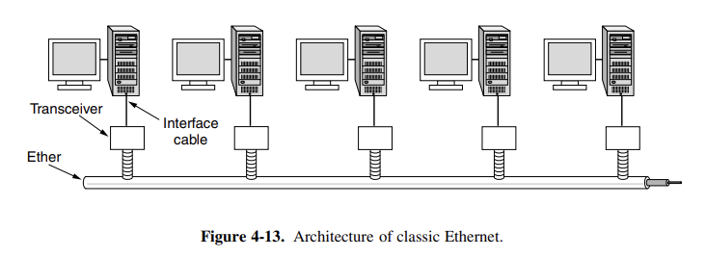• **802.3**: **Ethernet**. This is one of the most important standards. Classic Ethernet physical layer is discussed in the sources. Fast Ethernet is defined as 100Base-T4, 100Base-TX, and 100Base-FX, running at 100 Mbps. Gigabit Ethernet (IEEE 802.3ab) maintains compatibility  
  
  
  
